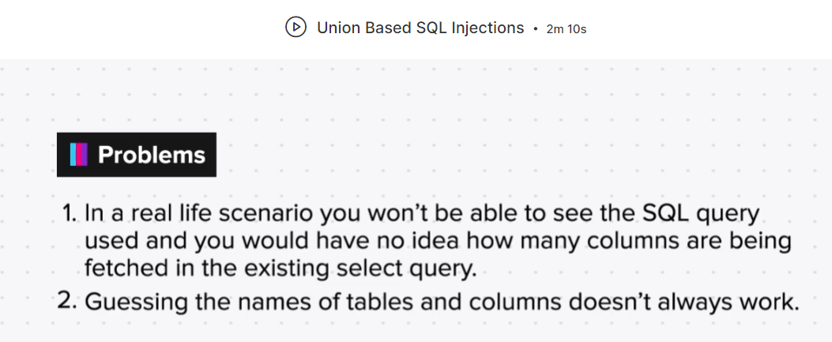

1. Finding Number of Column in SQL Query:

i. Hit and Trial Method

ii. Orderby Query

1. Guessing Names of Column:

i. Information Schema Exploit